OBBBA - 2026 Tax Updates

Item | Benefit Limit | Condition | Phase-out (Single/Joint)
Increased
Child Credit | +$200 to $2,200/Child
Senior Deduction | MFJ: 31,500+1600/spouse+6000/spouse = One Senior 39,100; Both Senior 46,700  Single: 15,750+2000+6000 = 23,750  HOH: 23,625+2000+6000 = 31,625 |  | $6,000 Phase-out:  $75K – $175K  / $150K – 250K  ($60 per $1000)
State and Local Taxes (SALT) | +$30,000 to $40,000 | Prepayment of Property Tax qualified  Pass-thru Entity Tax Payment unaffected | $500K – $600K ($300 per $1000)  ($250K - $300K if filing separately)
New Deduction – MFS Not Qualified
Overtime Pay | Up to $12,500 / $25,000 | The “Half” portion of the “Time-and-a-Half”  Reported on W2/1099/Other Statement/ or by Employee | $150K – $275K  / $300K – 550K  ($100 per $1000)
Tips | Up to $25K (Single or Joint)  Or up to Self-Employment Net Profit | Employees, Self-Employed  Reported on W2/1099  Employer/Payer must file Information Returns | $150K – $400K  / $300K – 550K  ($100 per $1000)
Car Loan Interest | Up to $10K Interest (Single or Joint) | Purchased in 2025, VIN 1, 4, 5, or 7 (2 Canada, 3 Mexico, 6 Australia/New Zealand, Letter Europe)  <14,000 lb, Personal use only  Refi eligible | $100K – $150K  / $200K – $250K  ($200 per $1000)
Other Benefits
Trump Accounts  (IRS Form 4547) | The government contributes $1,000 to each New-Born (after 01-01-2025)  Individuals/Employers contribute up to $5,000 per Child  Employers contribute up to $2500 per Employee tax-free to the Employee | Open by Authorized Parents/Guardians  Cannot withdraw before 18-Y  Withdraws between 18 and 59 ½ subject to Penalties --- First-time home purchase, Medical, Education are exceptions | No Income Limit

HSA Additional Coverage |  | Telehealth  Bronze Plans, Catastrophic Plan
Expires
EV Credit |  | After Sep 30 2025
Energy Credit | Solar, AC, Furnace, Doors, Window, Insulations … | After Dec 31 2025
No Changes
Other Dependent Credit |  | $500 – No Change
Mortgage Interest |  | No Change – $750K Deductible Personal Mortgage Loan
Miscellaneous Deductions: Casualty Losses, Moving Expenses, Gambling Losses |  | No Change
Business Taxes
- QBI Deduction 2026 | Minimum $400 QBI deduction starting in 2026, for taxpayers with at least $1,000 in QBI
- Bonus Depreciation | Reinstated 100% bonus deprecation  -- Since bonus depreciation now covers new and used equipment, the benefits of Section 179 would only apply to specific business circumstances.

Trump Accounts
 | Income Requirements | Contribution Limits | Contribution Tax Benefits | Withdraw Tax Liabilities
Trump Accounts | No | Total: $5,000/Y | Individuals: After-tax dollars (Non tax deductible)  Federal Government: $1000 contribution to a new-born tax-free  Employers: Before-tax dollars (up to $2500 up to $2500 per Employee tax-free to the Employee) | --- Earnings subject to income tax;  --- Government/Employer Contributions subject to income tax;  --- Withdraws before 59 ½ subject to 10% Penalties (with some exceptions)
529 Plans |  | No Limit, but subject to Gift Tax Reporting rule | After-tax dollars (Some states are tax-deductible) | --- No income tax on qualified education expenses;  --- No age restrictions
Traditional IRA’s | The child must have Earned Income | $7,500 for 2026 | Pre-tax dollars (Tax deductible) | --- Both contributions and earnings subject to income tax;  --- Withdraws before 59 ½ subject to 10% Penalties (with some exceptions)
ROTH IRA’s | The child must have Earned Income | $7,500 for 2026 | After-tax dollars (Non tax deductible) | --- No income tax on withdraws;  --- Withdraws Earnings before 59 ½ subject to 10% Penalties (with some exceptions)
How to sign up?
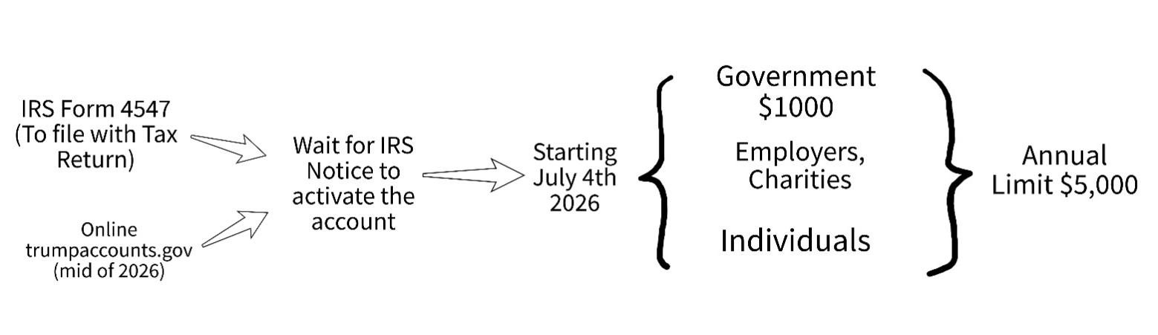

www.bandrtax.com Tax Handbook

Tax Rate - 2025 Tax Year
Married Filing Jointly Taxable Income
0 | 23,850 | 10% -0 = Tax
23,851 | 96,950 | 12% -477 = Tax
96,951 | 206,700 | 22% -10,172 = Tax
206,701 | 394,600 | 24% -14,306 = Tax
394,601 | 501,050 | 32% -45,874 = Tax
501,051 | 751,600 | 35% -60,905 = Tax
751,601 |  | 37% -75,937 = Tax

Single Taxable Income
0 | 11,925 | 10% -0 = Tax
11,926 | 48,475 | 12% -238 = Tax
48,486 | 103,350 | 22% -5,086 = Tax
103,351 | 197,300 | 24% -7,153 = Tax
197,301 | 250,525 | 32% -22,937 = Tax
250,526 | 626,350 | 35% -30,452 = Tax
626,351 |  | 37% -42,979 = Tax

Married Filing Separately Taxable Income
0 | 11,925 | 10% -0 = Tax
11,926 | 48,475 | 12% -238 = Tax
48,486 | 103,350 | 22% -5,086 = Tax
103,351 | 197,300 | 24% -7,153 = Tax
197,301 | 250,525 | 32% -22,937 = Tax
250,526 | 375,800 | 35% -30,452 = Tax
375,800 |  | 37% -37,968 = Tax

Head of Household Taxable Income
0 | 17,000 | 10% -0 = Tax
17,001 | 64,850 | 12% -340 = Tax
64,851 | 103,350 | 22% -6,825 = Tax
103,351 | 197,300 | 24% -8,892 = Tax
197,301 | 250,500 | 32% -24,676 = Tax
250,501 | 626,350 | 35% -32,191 = Tax
626,351 |  | 37% -44,718 = Tax

LT Capital Gain
Taxable Income – Deduction to Reduce Ordinary Income First
 | 0% | 15% | 20%
MFJ | 0-96,700 | 97,701-600,050 | 600,051-
Single | 0-48,350 | 48,351-533,400 | 533,401-
MFS | 0-48,350 | 48,351-300,000 | 300,301-
HOH | 0-64,750 | 64,751-566,700 | 566,701-

IL Filing Requirement & Dependent Exemption
> 2,850 (IL Exemption)
If a Dependent’s Illinois Income <= $2,850,
Then the Exemption is $2,850.
If a Dependent’s Illinois Income > $2,850,
Then the Exemption is $0.

Standard Deduction & Filing Requirement
Filing Status | Standard Deduction | Additional for 65+ | New for 65+ | Total for Seniors
MFJ | 31,500 | 1600 per spouse | 6000 per spouse | One: 33,100 - 39,100  Both: 34,700 -46,700
Single / MFS | 15,750 | 2000 | 6000 | 17,750 - 23,750
HOH | 23,625 | 2000 | 6000 | 25,625 - 31,625
$6,000 Phase-out: $75K – $175K / $150K – 250K
($60 per $1000)

MFS Filing Requirement: $5
Blind: Single/HOH +2000; MFJ/MFS +1600

Filing Requirement for Dependent
AGI
Dependent Must File When | Earned Income > 15,750 or  Unearned Income > 1,350 or  Earned and Unearned Income > Earned Income +450 or  Self-Employment (Net) > 400
Senior Dependent Must File When | Earned Income > 16,150 or  Unearned Income > 2,850 or  Earned and Unearned Income > Earned Income +2000 or  Self-Employment (Net) > 400
Self-Employment Must File When | Self-Employment (Net) > 400

Standard Deduction for Minor, Adult, Senior and Blind Dependent

Minor and Adult
$1,350 or
Earned Income + $450 up to $15,000

Senior and Blind
Senior X1, Senior Spouse (when both are dependents) X1, Blind X1

Single / HOH: + $2000 Xn --- addition
MFJ / MFs: +$1600 Xn/ea person --- addition

Additional Child Tax Credit
- Up to $1,700 per child ($2,200 total child tax credit, with $1,700 refundable).
- Child must be < 17
- You must have earned income of at least $2,500.
- (Earned Income - $2,500) * 15%, upto $1700

Children Unearned Income Tax Rate
0 - 1,350 | 0%
1,350 – 2,700 | Child’s own tax rate
> 2,700 | Parent’s tax rate – Kiddie Tax

Qualifying Relative (for Other Dependent Credit) Income Limit: $5,200
(SS Not Count towards Senior Dependent’s Income Test)

Child Care Credit (Non-Refundable)

<= 12 Year Old; Both Parents Working
Summer Camp Included
1 Child Expense: up to $3000
2+ Children: up to 6000
(also if Employer dependent benefit > $3000 / $6000, no more Credit)
AGI:
<15000 | 35%
15000-25000 | 34% - 30%
25000-35000 | 30% - 25%
35000-43000 | 25% - 20%
>43000 | 20%

MFS Lost Benefit:

Potential Benefit:  State tax savings (when one spouse lives in high-tax state and the other spouse lives in very-low-tax state)  Medical expenses deduction (when medical expenses if over 7.5% of one spouse AGI)  Child credit (when joint AGI is too high to be qualified for child credit --- but beware of the higher tax bracket the high-income spouse will be facing if MFS) | Lost Benefit:  - Earned income credit  - Child and dependent care expenses credit  - Education credits (AOTC and LLC)  - Student loan interest deduction  - Capital loss deduction limit is $1,500 (instead of $3,000)  - Your rental loss allowance limit is $12,500 (instead of $25,000).  - If your spouse itemizes deductions, you can’t claim the standard deduction.

Education Credit ($1500 Non-Refundable; $1000 Refundable)

MAGI* = AGI + Foreign Income Exclusion
1040NR not qualified
 | AOTC (up to 2,500)  (2,000 for 2,000 then 500 for 2,000-4,000) | LLC (20% of Tuition up to 10K Tuition)
1098T? | 1098-T Required | 1098-T Required
Degree? | Must be pursuing a degree | Courses for job skills qualified
Enrollment? | at least part time for one semester | one course OK
Books/Material? | Tuition, Fees, and Books/Material | Tuition, Fees
MFJ | AGI* < 160K  160K-180K (5% decrease per 1K) | AGI* < 160K  160K-180K (5% decrease per 1K)
Single/HOH | AGI* <80K  80K-90K (10% decrease per 1K) | AGI* <80K  80K-90K (10% decrease per 1K)
MFS | NO | NO
IRS Pub 970
Student Loan Interest: Max $2,500
MAGI* = AGI + Foreign Income Exclusion
Phase-out: Single/HOH: 85K-100K;
MFJ: 170K-200K

Educator Expense Deduction: $300/p
IL K-12 Classroom Material Credit: $500/p

529 Plan Rollover to ROTH:
Lifetime $35K/Beneficiary (subject to the annual Roth IRA contribution limit)

Obama Care Repayment
Household Total Income as % of Poverty Level (“MAGI**” + Dependent “MAGI**”) 2026
Family size | Poverty Line | 200% | 300% | 400%
1 | $15650 | $31,300 | $46,950 | $62,600
2 | $21,150 | $42,300 | $63,450 | $84,600
3 | $26,650 | $53,300 | $79,950 | $106,600
4 | $32,150 | $64,300 | $96,450 | $128,600

Applicable Figure
How Much Total HH Income Above National Poverty Line | Taxpayer Contribution Req’d
< 133% | 2.1%
133% | 3.14%
138% | 3.45%
150% | 4.19%
200% | 6.6%
250% | 8.44%
300-400% | 9.96%
>400% | Ineligible for PTC
Form 8962 Instructions
Taxpayer Contribution Required = Total “MAGI**” Applicable Figure
Medical Insurance Premium Tax Credit Allowed = SLCSP
(Second Lowest Cost Silver Plan Premium) - Taxpayer Contribution Required
Repayment Limitation 2025
 | Single | All Others
< 200% | 375 | 750
200%-300% | 975 | 1,950
300%-400% | 1,625 | 3,250
> 400% | 8.5% Total “MAGI**” | 8.5% Total “MAGI**”
Form 8962 Instructions

HSA Contribution Limit

- High Deductible Health Plan Required
- Medicare Not Eligible
- FSA / HRA generally not qualified for HSA
- Unearned Income / No Income still OK
04/15/2026 | <55 | >55
Self-only | 4,300 | 5,300
Family | 8,550 * | +1000/each
*MFJ who both have an HSA-qualified plan must share a family HSA contribution limit of $8,550. Contribution Limit in HAS Form 8889 for each spouse is $4,275

FSA Contribution Limit

By 12/31/2026 3,400

Excess HSA Contribution

Remove the excess contribution through a distribution by 4/15 (or 10/15), and withdraw income earned on the excess contribution(s) and including it on your tax return for that year.
Pre-tax contributions and the earnings should be included in the employee’s W2, or reported as "other income" on the tax return. Post-tax contributions would not be taxable as income, but the earnings would be taxable as income.

Long-Term Care Premium Deduction on Schedule A
< Age 40 | $500
Age 40 - 50 | $930
Age 50 - 60 | $1,860
Age 60 - 70 | $4,960
> Age 70 | $6,200

Earned Income Credit (Refundable)

AGI
– Dependent is younger than TP
- Dependent is under 19 (or 24 Full Time Student)
- Or disabled
- Not Married Filing Separately
- No Foreign Income
- Investment Income < 11,950
- TP Must between 25 – 65 Years Old

0 Children --- $649 Max
 | 0 Children | Peak
MFJ | < 26,250 | 8,450-17,750
Single, HOH | < 19,150 | 8,450-10,650

1 Child --- $4,328 max
 | 1 Child | Peak
MFJ | < 57,600 | 12,700-30,500
Single, HOH | < 50,450 | 12,700-23,350

2 Children --- $7,152 max
 | 2 Children | Peak
MFJ | < 64,450 | 17,850-30,500
Single, HOH | < 57,350 | 17,850-23,350

3 Children --- $8,046 max
 | 3 Children | Peak
MFJ | < 68,700 | 17,850-30,550
Single, HOH | < 61,600 | 17,850-23,350
Form 1040 Instructions

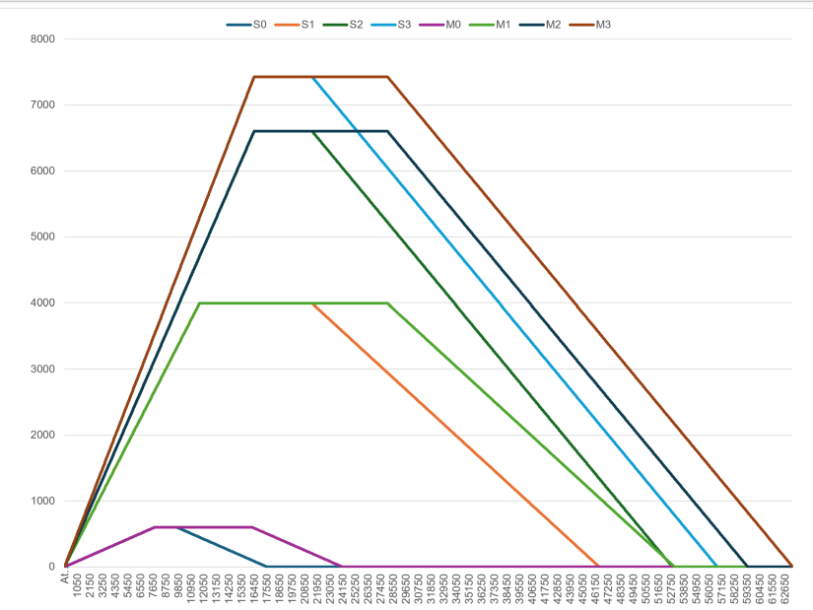

RMD
--- Age 73, first RMD by April 1st of NEXT year
--- Inherited IRA: Entire balance must be withdrawn by the end of the 10th year
--- Spousal Transfer: Spread over the deceased remaining life expectancy, or the surviving spouse’s single life expectancy, whichever is longer.
--- Minor Children: 10-Year rule begins when they turn 21
--- IRAs and 403(b)s: can aggregate RMD amounts and withdraw the total from ONE or MORE accounts
--- 401(k)s: must calculate the RMD separately for each account and take it individually from each account

Uniform Lifetime Table
Age |  | Age
73 | 3.77% | 80 | 4.95%
74 | 3.92% | 81 | 5.15%
75 | 4.07% | 82 | 5.41%
76 | 4.22% | 83 | 5.65%
77 | 4.37% | 84 | 5.95%
78 | 4.55% | 85 | 6.25%
79 | 4.74% | 86 | 6.58%

*Single Life Table is for beneficiaries to calculate RMDs after inheriting an account

QCD
Qualified Charitable Distribution. For age 70½ +. From a traditional IRA or a Roth IRA, cannot take from 401(k)s however. Not counted as taxable income. Count toward RMD.

SECURE 2.0 Act
Emergencies --- you can withdraw up to $1,000 from a retirement account, but you’d have to replace those funds in the next three years before you can make another similar withdraw.
Employers can match your student loan payments instead of retirement matches.

FICA Rate
SS 6.2% + Med 1.45% = 7.65%
Employer 7.65% + Employee 7.65% = 15.3%
Self-Employed: 12.4% (SS) + 2.9% (Med) = 15.3%

MAGI calculation
AGI
+ Non-taxable SS (incl SSDI, but excl SSI) (1)
+ Tax-exempt interest (2)
+ Foreign earned income & housing exclusion (3)
+ IRA / SEP Deduction
+ Student loan interest
+ Educator expense
+ 1/2 of self-employment tax; SEHI;
+ Rental loss; public-traded partnership loss;
+ Other passive loss;
(1) (2) (3) for ACA (Affordable Care Act) MAGI** Purpose

Retirement Savings Credit (Non-Refundable)
AGI | MFJ | HOH | Single, MFS
50% | < $47,500 | < $35,625 | < $23,750
20% | $47,501- $51,000 | $35,626 - $38,250 | $23,751- $25,500
10% | $51,001 - $79,000 | $38,251- $59,250 | $25,501 - $39,500
IRS Retirement Savings Contributions Credit

Form 4797 vs Form 8949 or Schedule D

Form 4797 | Form 8949 | Schedule D
Business assets  for producing income | Investment properties  didn’t produce income before the sale | Use Form 8949 to report Form 1099-B or 1099-S. The subtotals from this form will then be carried over to Schedule D, where gain or loss will be calculated in aggregate.
Rental property | Land held for investment
House for flip | Investment (second) home that didn’t produce income before the sale
Business equipment  e.g. a computer used for business | Personal assets  e.g. a personal computer
 | Stocks, Bonds
Losses are Section 1231 Loss,  The net loss to offset ordinary income  Nonrecaptured Net 1231 Losses to carry over for 5 years | Losses are Capital Loss to offset other capital gains, or up to $3000 to offset ordinary income
Net gain is long term capital gain (after recaptured 1231 losses from previous years)

Defined Contribution Plans
2026 | Regular Contribution:  Note: 100% Contribution subject to a Mechanical Floor, to maintain enough cash to pay FICA tax etc. | 50 and Older | Deadline: Deposit after payday + 7 biz days is Safe Harbor for small business (<100 participants); + 15 biz days Max
401K, 403b, 457, TSP | 24,500 or 100%comp.  Employer upto 25%comp.  *** The $72K Limit | +8,000 (to 32,500)  60-63: +11,250 (to 35,750) *** The $80K /$83,250 Limit | Employee: 12/31 (7-15d deposit)  Employer: Per-Payroll Matching: by End of Next Quarter; Yearend Lump Sum Matching: Tax Return Due Date incl. Extensions
401K: The Actual Deferral Percentage (ADP) Test is a non-discrimination test ensure that 401(k) plan does not disproportionately benefit executives and owners at the expense of lower-earning employees.
Highly Compensated Employees (HCEs): Owned more than 5% of the company, OR earned above the IRS threshold in the previous year (e.g., $160,000 earned in 2025 determines HCE status for 2026).
Non-Highly Compensated Employees (NHCEs): All other eligible employees.
To pass the test, the average ADP for HCEs cannot exceed the average ADP for NHCEs beyond specific spreads.
To avoid the ADP Test: Safe Harbor 401(k) --- automatically exempt from the ADP test, allowing HCEs to contribute up to the maximum IRS limit. Safe Harbor options include: Basic Match: 100% match on the first 3% + 50% match on the next 2%, etc.
Profit Sharing Plan: A discretionary, tax-deductible employer contribution to a Defined Contribution plan (most often a 401(K), though it can exist as a standalone plan. The employer decides each year whether to make a contribution and how much to contribute.
NOT subject to ADP Test. BUT still needs to satisfy other IRS non-discrimination rules.
Profit Sharing Plan: | Employer upto 25%comp.  Employee Deferrals + Employer Match + Employer Profit-Sharing <= The $72K Limit | The $80K /$83,250 Limit | Tax Return Due Date incl. Extensions
SIMPLE IRA, SIMPLE 401K  ROTH SIMPLE IRA  ^^^ <= 25 Employees | 17,000; ^^^18,100  or 100%comp. Employer 3% (req. 3% or “nonelective” 2%) | +4,000 (to 21,000)  ^^^+3,850 (to 21,950)  60-63: +5,250 (to 22,250) ^^^+5,250 (to 23,350) | Employee: 12/31 (7-15d deposit)  (Employer Match: 4/15 or 10/15)
SEP | 25% of W2 (up to 360K).  Self-Employed 20% * (Net - Half of SE Tax), effective rate: 18.58%  The $72K Limit | No Diff. | 4/15 or 10/15
Solo 401K --- Self + Spouse (double the benefit) | (Same as 401K)  Exempt from the Non- discrimination Testing; File Form 5500-EZ instead of Form 5500 |  | Employee: 12/31 (7-15d deposit)  Employer: Tax Return Due Date incl. Extensions
Deductible IRA | 7,500 | 8,600 | 4/15
ROTH | 7,500 | 8,600 | 4/15
Backdoor ROTH: Step 1: Nondeductible IRA; Step 2: ROTH Conversion. Cannot choose to convert only your after-tax contributions. Conversions consist of a matching ratio of pre-tax and after-tax money --- Pro-Rata Rule, requires to aggregate all Traditional IRA, SEP, and SIMPLE IRAs and treat them as a single combined account
Backdoor ROTH: | 7,500 | 8,600 | 12/31
ROTH Conversion | No Limits |  | 12/31
Mega Backdoor ROTH Conversion: Requires the Company’s Retirement Plan
(1) Allows After-tax 401K contributions (2) Allows After-tax 401K move to a ROTH 401K or a ROTH IRA
Pre-tax 401K + ROTH 401K + Employer Contribution + After-tax 401K <= The $72K Limit (or The $80K /$83,250 Limit)
Convert the After-tax 401K to ROTH 401K or ROTH IRA
Multi-job Contributions: All 401K’s + All Simple IRA’s, Total Employee Contribution <= 24,500 (or 32,500 / 35,750)
Employer Contribution: upto 25%comp. / Job; and The $72K Limit (or $80K /$83,250 ) / Job

Defined Benefit Plans (Pension) and NQDC Plans
Defined Benefit Plans (Traditional Pension, e.g. IL IMRF): Employer commits to paying benefit that is fixed by formula. Calculated by actuaries. Employer, not the employee, bears the investment risk. Mandatory Minimum Funding: Employer is required to contribute enough each year to keep the plan on track to pay the benefits it has promised.
Maximum Annual Payout at Retirement: 290,000;
Maximum Compensation Cap Used to Calculate Target Retirement Benefit: 360,000
Defined Benefit Plans (Traditional Pension, e.g. IL IMRF): | Employer: commits to paying benefit that is fixed by formula. If plan investments underperform, the employer has to contribute more to make up the shortfall; if they outperform, contributions can be reduced. | Employee: Fixed, Mandatory Payroll Deductions, typically in the 5–8% range; No Catch-up Contribution | Deadline: Mandatory Minimum Funding Deadline: 9/15  Deadline for Tax Deduction: Deposit Deadline: Tax Return Due Date incl. Extensions (3/15, 4/15, 9/15, 10/15)

Nonqualified Deferred Compensation Plans (NQDC) --- For Highly Compensated Employees and Key Executives. A portion of their earned compensation is legally agreed to defer to a future tax year.
Non-Qualified / “Unfunded” Because --- Not protected from creditors;
--- Contribution Not tax deductible by the employer;
--- Not includable in the employee’s taxable income (W2 Box 1); Subject to FICA and FUTA taxes (W2 Box 3, Box 5);
--- Distributions tax deductible for employer; taxable for employee (shows up in W2 Box 1, but not in Box 3, Box 5)
--- No 10% penalty for pre-age 59½ distributions;
--- No ADP Test
--- Can invest in “Rabbi Trust”, Tax- deferred Corporate-owned Life Insurance etc.
Nonqualified Deferred Compensation Plans (NQDC) | Employer makes discretionary contributions—such as executive retention bonuses or a Supplemental Executive Retirement Plan (SERP)  Or: Combined Employer’s and Employee’s Funding | Employee defers a portion of their earned compensation (base salary, commission, or bonuses) into the plan before taxes. | The Election must be made before 1/1

IRA and ROTH
2026 MAGI | IRA | ROTH
Contribution Limit | 7,500 (50 and older 8,600) Combined (Deductible IRA + Non-deductible IRA + ROTH)
If Individual is covered by company’s plan | MFJ: 129K-149K  Single/HOH: 81K-91K  MFS: <10K | MFJ: 242K-252K  Single/HOH: 153K-168K  MFS: <10K
If Individual is not covered but Spouse is covered | MFJ: 242K-252K | MFJ: 242K-252K  Single/HOH: 153K-168K  MFS: <10K
If Both are not covered by company’s plan | Full deductible no matter how much income | MFJ: 242K-252K  Single/HOH: 153K-168K  MFS: <10K

Excess Contribution
(1) Return the excess contribution back to you by 4/15 (or 10/15 with extension) to avoid penalty --- must include the earning of the excess contribution as well. Report the earnings on your tax return for the year.
Or (2) Apply the excess contribution to a later year. It doesn’t, however, let you avoid the 6% tax penalty on any excess contributions remaining at the end of a tax year.

Rental Loss Deduction Limitation
MAGI* = AGI + Foreign Income Exclusion
Single or MFJ
< 100,000 | 100,000 – 150,000 | >150,000
25,000 | 500 Less / 1K | None
MFS
< 50,000 | 50,000 – 75,000 | >75,000
12,500 | 500 Less / 1K | None

3.8% Net Investment Income Tax (NIIT) & 0.9% Additional Medicare Tax
(Medicare Tax 2.9% + 0.9% = 3.8%)
For NIIT: AGI + Foreign Income Exclusion
For Additional Medicare: W2 Box 5 & Sch. SE
MFJ | > 250K
Single / HOH | > 200K
MFS | > 125K
NIIT: Applies to Int, Div, Capital Gains, Rental, Royalty, Business Passive Income
Not Applies to Self-employment, Unemployment, Alimony, Tax –exempt Int

Additional Medicare: Applies to All Wages currently subject to Medicare Tax.
E.g, wife’s job income 230K, husband SE net income 70K. Workplace withholds 0.9% Medicare tax for wife’s 30K (no employer match required), husband pays estimated tax for 20K*0.9% (230K+70K-250K-30K=20K)

IRS Approved Modernized e-File (MeF) Business Providers

1031 Like-Kind Exchange
--- 45-Day: Contract / 180-Day: Closing

--- Rental Property only, owned > 1 Year;
Primary home, Secondary Not qualify

--- to Keep for at least 2 years, to rent >14 days/year, to live <14 days/year

--- The property was exchanged > 5 years ago

--- Depreciation reset to 27.5/39

--- Taxable Boot, taxed at Capital Gain Tax Rate.
if Purchase Price for New < Selling Price from Old (Cash Boot),
Or if New Mortgage Debt < Old Mortgage Debt

Line 12, Line 13 = 0,

Line 15 = Boot, Capital Gain Tax

Line 21 = 0

Line 16 = Purchase Price the Property Received, including Closing Cost

Line 18 Adjusted Basis of the Property Given-up = Purchase Price the Property Given-up,
including Closing Cost +
Capital Improvement –
Accumulated Depreciation +
Closing Cost of Selling the Property Give-up + Closing Cost of Purchasing Property Received + Net Debt/Liability Increase (Purchase Price for New – Selling Price from Old / New Mortgage – Old Mortgage)

Basis of like-kind property received = Adjusted Basis Gave Up; or the new property (if less)

High Income Earners
MFJ | SGL, HOH, MFS | Category | Not Allowed
MAGI* >100,000  MFJ, SGL, HOH | >50,000 (MFS) | Rental Loss Deduction | >150,000  (>75,000)
MAGI* >170,000 | >85,000 | Student Loan Int. | >200,000  (>100,000)
MAGI* >160,000 | >80,000  SGL, HOH  >0 for MFS | AOTC  &  LLC | >180,000  (>90,000)
MAGI >242,000 | >153,000 | ROTH  IRA (both no 401K) | >252,000  (>168,000)
MAGI* >250,000  W2 Box 5 + SE > 250,000 | >200,000  SGL, HOH  >125K MFS | NIIT  Add. Med. Tax
AGI >400,000  (-50 / 1K) | >200,000  (-50 / 1K) | Child Tax Credit | 440K,480K  240K,280K
AGI >500,000 | >250,000 | IL Property Tax Credit  K-12 Education Credit  IL Exemption | >500,000  (>250,000)
MAGI* = AGI + Foreign Income Exclusion

High Income Earners Recommendations

Business purchase of vehicles – ref. to “Section179 Deduction + Bonus Depreciation”
Other business purchases
Maximize defined-contribution plans (410K etc.)
Backdoor ROTH
HSA, 529
Non-deductible IRA: growth tax-deferred
Defined benefit plans --- pensions
Nonqualified deferred compensation plans --- no limits
“Creative Accounting”

Self-Employed?
No Ownership but Employed | N
Independent Contractor or Freelancer | Y
Sole Proprietor | Y
General Member of a Business Partnership | Y
Limited Member of a Business Partnership | N
Owner of an LLC | Y
Owner of an S Corp | N
Owner of an C Corp | N
Passive Income from Business Investment | N
Owner of a Rental Property | N*
* Unless operating as a business – cleaning, security etc.

Type of Income
Earned Income | W2, Sch C  Sch E and Sch F in some cases
Portfolio Income | Interest, Dividends, Stock Gains, Capital Gains from Selling Assets
Passive Income | Rental, Royalties, Passive Business Investment, Limited Partnership
Non-Passive Income | S Corp K-1

Illinois Alimony
Annual Alimony = (33% of the payer’s net income) – (25% of the recipient’s net income)
Years Married and Years Maintenance
< 5Y | 2 Y |  | 13 Y | 5.6 Y
6 Y | 2.4 Y |  | 14 Y | 6.0 Y
7 Y | 2.8 Y |  | 15 Y | 6.4 Y
8 Y | 3.2 Y |  | 16 Y | 6.8 Y
9 Y | 4.0 Y |  | 17 Y | 7.2 Y
10 Y | 4.4 Y |  | 18 Y | 7.6 Y
11 Y | 4.8 Y |  | 19 Y | 8.0 Y
12 Y | 5.2 Y |  | > 20 Y | Permanent maintenance or equal to the length of the marriage

Form 8846 Credit for Employer FICA Paid on Employee Tips

Stock Options

– Contract / Promise
– Vest / Grant
– Exercise / Buy / Purchase
– Sell
 | ESPP | RSU
 | Options to exercise (purchase) company shares on a future date with the current (or predetermined) price, and a discount (5%-15%) on Vesting Date | Pledges or promises or contract of company shares, but restricted until Vesting Date (e.g. 25% of the shares is vested on the date); Granted at Vesting Date price; and can be sold or after Vesting Date.
Waiting Period for Exercise and Sale | A few months / 1Y / 2Y after the Vesting Date | Between Promise Date --- Vesting Date
Add to W2 – Adjusted Amount (ordinary tax rate) | Market Value at Exercise Date – Predetermined Value with Discount at Vesting Date | Full Market Value at Vesting Date
Stock Gain (ST or LT) | Sale Price – Adjusted Cost Basis (on W2) | Sale Price – Adjusted Cost Basis (on W2)

Preferred stocks are senior (higher ranking) to common stock but subordinate to bonds in terms of claim.

QBI
Sum of:
Schedule C + Schedule E (Rental) + K1 (QBI Screen) – Losses and Carried QBI Losses

Taxable Income Before QBI
Single, HOH, MFS | MFJ | Qualified Trade or Business | Special Services *
<197K | <394K | 20% | 20%
197K-247K | 384K-494K | W2 Wages limit (shareholder portion of the W3): 50% W2 or 25% W2+2.5% Dpr Basis | W2 Wages limit (shareholder portion of the W3): 50% W2 or 25% W2+2.5% Dpr Basis
>247K | >484K | W2 Wages limit (shareholder portion of the W3): 50% W2 or 25% W2+2.5% Dpr Basis | NO
* health, law, accounting, performing arts, consulting, athletics, financial, investment management

Bonus Depreciation
OBBBA reinstated 100% bonus deprecation. Since bonus depreciation now covers new and used equipment, the benefits of Section 179 would only apply to specific business circumstances.

Section179 Deduction;

Bonus Depreciation
* Immediate deduction related to depreciable assets such as equipment, vehicles, and software, rather than capitalizing an asset and depreciating it over time in future tax years.
** Section 179 tax deductions require your company to be in the black (Business Income Limit) --- deduction limited to the taxable income from the trade or business
*** Bonus depreciation can be used even if your business is not profitable.
**** If either Section 179 expensing or Bonus Depreciation is used by a taxpayer, the standard mileage rates cannot be used for ANY periods after the year that depreciation is taken. Actual auto expenses (fuel, tires, repairs, etc.) must be tracked going forward.
***** A Form 1065 or Form 1120S entity does not include Section 179 Expense in the business deductions. Instead, it is passed through separately to the partners and shareholders' Schedules K-1.

Gift and Estate Exclusion
2026 Gift Tax Annual Exclusion | 19,000
Estate and Gift Tax Lifetime Exclusion | 15M / person
Gift to Non-Citizen of the US | 194,000

Trust Tax Rate
0-3150 | 10% | 11451-15650 | 35%
3151-11450 | 24% | 15651+ | 37%

 | Form 709 Gift Tax Return |  |  |  | Form 706 Estate Tax Return
Calendar Year (not Tax Year) | Total Rtns Filed | Taxable Rtns | Gift Tax Liab. |  | Total Rtns Filed | Taxable Rtns | Estate Tax Liab.
2023 |  |  |  |  | 7100 | 4000 | 24B
2022 |  |  |  |  | 7600 | 3900 | 22.7B
2021 | 250827 | 1813 | 2.8B |  | 6200 | 3500 | 19.2B
2020 | 174026 | 516 | 0.4B |  | 4100 | 1900 | 16B
2019 | 248821 | 1026 | 1.2B |  | 4100 | 1900 | 15.6B

Mileage Deduction
70 ₵
Mileage Deduction (No commuting miles) | Actual Expenses Method
Not allowed: Lease Payment, Car Depreciation, Car Loan Interest, Car Lease Expenses, Fuel, Insurance, License Plate, Registration, Repair and Maintenance (e.g New Tires), Car Wash, Garage Rent | Allowed
Allowed: Car Loan Interest, Parking (not at your business location) and Tolls, Personal Property Tax | Allowed
Need to choose his method in the 1st year in order to use it in any year, and can switch back and forth between the two methods | If choose this method in the 1st year, then required to continue to use it for the rest of the vehicle life
Can’t choose this method if you have five or more vehicles on the road at the same time
Can’t choose this method if claimed any deprecation other than the Straight Line

Medicare Premiums
Income-Related Monthly Adjusted Amount (IRMAA)
Plan A Zero, to Full Price $505
MAGI (2025 based on 2023 AGI)
Single | Married Filing Jointly | Medicare Part B Monthly | Medicare Part D Monthly
< $109,000 | < $218,000 | $202 | $Base
$109,000- $137,000 | $218,000 - $274,000 | +81=$284 | $Base +$14
$137,000 - $171,000 | $274,000 - $342,000 | +203=$405 | $Base +$37
$171,000 - $205,000 | $342,000 - $410,000 | +324=$527 | $Base +$60
$205,000 - $500,000 | $410,000 - $750,000 | +446=$649 | $Base +$83
> $500,000 | > $750,000 | +487=$689 | $Base +$91
Google AI, SSA-44

Full Retirement Age:
< 1954: 66 1954-60: 66 and months
>1960: 67

Social Security Earning Limit 2026
Wage Base: $184,500 www.ssa.gov
< Ret. Age | Year of Ret. Age | > Ret. Age
24,800 or more: | 65,100 or more: | Unlimited
$1 withhold for every $2 earnings | $1 withhold for every $3 earnings | N/A
The withhold will increase monthly benefit at retirement age (exceptions: spouse, minor beneficiaries, disability benefits, supplemental benefits)
First-Year retirement: Full monthly benefit for any full month you retired, no matter how much earned before retirement.

Maximum SS Benefit
2026
$5,108/M ($61,296/Y) – Age 70
$4,108/M ($50,160/Y) – Full retirement age
$2,831/M ($33,972/Y) – Retiring at age 62

Maximum Social Security Taxable Earnings

2017 = 127,200 2018 = 128,400 2019 = 132,900
2020 = 137,700 2021 = 142,800 2022 = 147,000
2023 = 160,200 2024 = 168,600 2025 = 176,100
2026 = 184,500

How Much SS Taxable?
Combined Income CI (or “Provisional Income PI”) = AGI Excl. SS +
Nontaxable Interest + ½ SS Benefits
 | Single etc | MFJ | % Taxable
CI | Whatever < 25,000 | Whatever < 32,000 | 0%
CI | 25,000 – 34,000 | 32,000 – 44,000 | (CI with Half SS > 25000: 1 – 9000) * 50%, up to 4,500;  (CI with Half SS > 32000: 1 – 12000) * 50%, up to 6,000
CI | >34,000 | > 44,000 | (CI with Half SS > 34000) * 85%  CI with Half SS > 44000) * 85%  (2) Add Above Together  Compare with SS * 85%  Maximum SS * 85%
https://www.moneytree.com/resources/calculating-taxable-social-security-benefits/
Reduced Benefit v.s. Delayed Credits
Age | Benefit | Spousal |  | Age | Benefit | Spousal
62 | 70.0 | 32.5 |  | 66 | 93.3 | 45.8
62 + 1 | 70.4 | 32.7 |  | 66 + 1 | 93.9 | 46.2
… | … | … |  | … | … | …
62 + 11 | 74.6 | 34.8 |  | 66 + 11 | 99.4 | 49.7
63 | 75.0 | 35.0 |  | 67 | 100 | 50
63 + 1 | 75.4 | 35.2 |  | 67 + 1 | 100.7 | 50
…. | … | … |  | … | … | …
63 + 11 | 79.6 | 37.3 |  | 67 + 11 | 107.3 | 50
64 | 80.0 | 37.5 |  | 68 | 108.0 | 50
64 + 1 | 80.6 | 37.8 |  | 68 + 1 | 108.7 | 50
… | … | … |  | … | … | …
64 + 11 | 86.1 | 41.3 |  | 68 + 11 | 115.3 | 50
65 | 86.7 | 41.7 |  | 69 | 116.0 | 50
65 + 1 | 87.2 | 42.0 |  | 69 + 1 | 116.7 | 50
… | … | … |  | … | … | …
65 + 11 | 92.8 | 45.5 |  | 69 + 11 | 123.3 | 50
 |  |  |  | > 70 | 124.0 | 50

SS and Med Credit 2025
$1,810 per credit $7,240 four credits

SS Cost-Of-Living Adjustments (COLA)

COLA | Year |  | COLA | Year
8 | 1976 |  | 2.7 | 2005
6.4 | 1977 |  | 4.1 | 2006
5.9 | 1978 |  | 3.3 | 2007
6.5 | 1979 |  | 2.3 | 2008
9.9 | 1980 |  | 5.8 | 2009
14.3 | 1981 |  | 0 | 2010
11.2 | 1982 |  | 0 | 2011
7.4 | 1983 |  | 3.6 | 2012
3.5 | 1984 |  | 1.7 | 2013
3.5 | 1985 |  | 1.5 | 2014
3.1 | 1986 |  | 1.7 | 2015
1.3 | 1987 |  | 0 | 2016
4.2 | 1988 |  | 0.3 | 2017
4 | 1989 |  | 2 | 2018
4.7 | 1990 |  | 2.8 | 2019
5.4 | 1991 |  | 1.6 | 2020
3.7 | 1992 |  | 1.3 | 2021
3 | 1993 |  | 5.9 | 2022
2.6 | 1994 |  | 8.7 | 2023
2.8 | 1995 |  | 3.2 | 2024
2.6 | 1996 |  | 2.5 | 2025
2.9 | 1997 |  | 2.8 | 2026
2.1 | 1998
1.3 | 1999 ª
2.5 | 2000
3.5 | 2001
2.6 | 2002
1.4 | 2003
2.1 | 2004

Can I file for my Social Security at 62 and switch to spousal benefits later?
Only if your spouse is not yet receiving retirement benefits. In this case, you can claim your own Social Security beginning at 62 and make the switch to spousal benefits when your husband or wife files.
Social Security will not pay the sum of your retirement and spousal benefits; you’ll get a payment equal to the higher of the two benefits.
Can I apply only for spouse’s benefits and delay filing for my own retirement benefit to earn delayed retirement credits?
No, you are required to file for both your own retirement and for any benefits you are due as a spouse. This requirement is call deemed filing.
Spousal Benefit
--- Married for at least a year
--- You are at least age 62 (or care for a child under 16, or a disabled child)
--- The worker already filed SS benefits
--- Receive 32.5% - 50%, depends on age of the worker when he filed
--- May be reduced if you are under full retirement age and continue to work
--- If you are eligible for a retirement benefit based on your own earnings, and if that benefit is higher than the spousal benefit, then you will get your own retirement benefit. Note: Deemed Filing = You can't apply only for spouse’s benefits and delay filing for your own retirement benefit to earn delayed retirement credits.
Deceased Worker Spousal Benefit
--- Married for at least nine months
--- You are at least age 60, or at least 50 and disabled (or care for a child under 16, or a disabled child): 71.5% of the deceased worker’s benefit
--- You are between 60 (or 50 … or child … ) and your full retirement age: 71.5%
- 99% of the deceased worker’s benefit
--- You are at full retirement age: 100% of the deceased worker’s benefit
--- Deceased Worker’s Benefit:
if the deceased worker not yet reached full retirement age, then Deceased Worker’s Benefit = 100% of the benefit he would have been entitled to, based on lifetime earnings
if the deceased worker passed full retirement age, then Deceased Worker’s Benefit = delayed credit
--- May be reduced if you are under full retirement age and continue to work
--- If you are eligible for a retirement benefit based on your own earnings, and if that benefit is higher than the spousal benefit, then you will get your own retirement benefit. Note: Deemed Filing = You can't apply only for spouse’s benefits and delay filing for your own retirement benefit to earn delayed retirement credits.

Divorced Spousal Benefit
--- Married for at least 10 years
--- You haven’t remarried
--- You’re not eligible to receive a higher benefit based on your own work record,
--- You’re at least 62 years’ old
--- Your ex-spouse is eligible to receive Social Security retirement or disability benefits, even if they haven’t decided to start receiving them yet.

Divorced and Deceased Worker Spousal Benefit
--- Married for at least 10 years
--- You haven’t remarried before age 60 (or 50 if disabled)
--- Then the same rule as in “Deceased Worker Spousal Benefit”

Medicare Wages, Total Pay and Officer Compensations

W2 Box 5 (Medicare Wages) | Form 940 Line 3 (Total Payments to All) | Form 1120S Line 7 and 8 (Officer Compensation and Employee Salaries Wages) --- >2% Shareholders | Form 1120S Line 7 and 8 (Officer Compensation and Employee Salaries Wages) --- <2% or Non Shareholders | Form 1120S Line 17 (Pensions etc);  Form 1120S Line 18 (Employee Benefit Programs)
Total Wages + Defined Contribution Plans (401K, Simple IRA etc) + NQDC (Non-Qualified Deferred Compensation) | W2 Box 5 + Employee’s Pretax Contribution to Medical, Dental, Vision, Group Life, Dependent Care FSA, HSA (Section 125 Cafeteria) + Employer’s Contribution to Medical, Dental, Vision, Group Life etc + Employer’s Contribution to 401K, Simple IRA etc | W2 Box 5 (But see Note * below) +  Employer’s Contribution to Medical, Dental, Vision, Group Life etc because these benefits must also be included in the shareholder's taxable wages on Form W-2 (Box 1)  Note *: NQDC Non-Qualified Deferred Compensation should be included in the Distribution Year NOT in the Vest Year) | W2 Box 5 (But see Note * below) + Section 125 Cafeteria  Note *: NQDC Non-Qualified Deferred Compensation should be included in the Distribution Year NOT in the Vest Year) | Report Employer Contributions to retirement plans on Line 17  Report Employer’s Contribution to Medical, Dental, Vision, Group Life etc for <2% or Non Shareholders on Line 18
NOTE: Section 125 Cafeteria is not shown in W2 Box 1/3/5, but only sometimes an informational entry in Box 14. Box 10 is the one exception |  | NOTE**: >2% Shareholders is treated as partners and they are barred from participating in Section 125 Cafeteria. Any such amounts the S-corp pays or reimburses on their behalf have to be added to that shareholder's W-2 Box 1 wages instead. On the 1120S, that shows up as ordinary taxable compensation on line 7. The shareholder then may be able to claim a SEHI deduction on their personal Form 1040 | NOTE**: Section 125 Cafeteria is part of “Total Benefit” or “Total Salaries” that employer pays to Employee  Employer’s Contribution to Medical, Dental, Vision, Group Life etc are reported on Line 18

IRS Phone Numbers
Individuals： 800-829-1040 7 - 7 local time Businesses： 800-829-4933 7 - 7 local time

Taxpayer Advocate 1-877-777-4778

Local IRS office Appointment: 844-545-5640: Downers Grove, Schiller Park and Chicago

Practitioner Hotline (for Tax Preparer Professional Only): 866-860-4259

1040-NR: 267-941-1083 6 a.m. to 10 p.m. eastern time

Illinois Department of Revenue
800-732-8866 or 217-782-3336
Individual Tax | REV.TA-IIT@illinois.gov
Business Tax | REV.TA-BIT-WIT@illinois.gov
Sales Tax | REV.TA-Sales@illinois.gov
MyTax Illinois Help | REV.MyTaxHelp@illinois.gov

IRS Payroll Tax Deposit Schedule
Monthly depositor --- By the 15th day of the following month.
Semi-weekly depositor ---
Wed, Thu, Fri | (following) Wed
Sat, Sun, Mon, Tue | Fri
Next-day deposit rule --- If you accumulate $100,000 or more in taxes on any day then you must deposit by the next business day.

Deadlines for Refund and Amendment
 |  | Deadline to file an Initial Return to Claim Refund | Deadline to file an Amendment to claim a Refund | Drake E-Filing Window
2021 Tax | You filed a return on Apr 15 (or Oct 15), 2022 |  | Apr 15 (or Oct 15), 2025 | Jan 2022 – Dec 2024
2021 Tax | You filed a return on Jan 2023 |  | Jan 2026 | Jan 2022 – Dec 2024
2021 Tax | You withheld tax Jan-Dec 2021, but didn’t file a return | Jan 2023 to claim Credit for Jan 2021  “refund is limited to the amount you paid within the 2 years right before you filed your claim” |  | Jan 2022 – Dec 2024
2021 Tax | You filed an Amendment Return for 2021 in Apr 2025 and paid the Balance Due in Feb 2027 |  | Feb 2029 | Jan 2022 – Dec 2024

IRS Penalty and Interest

Reason | Type of Penalty | Amount of Penalty | First Time Penalty Abatement | Amount of Interest
Installment | Failure to Pay Penalty | 0.25% / M | N/A | Fed short-term rate plus 3%
< 90% of Current Year Tax Liability or  < 100% (110% for 150K +) of Prior Year Tax Liability | Underpayment of Estimated Tax Penalty | About 5% / Y | Yes | Fed short-term rate plus 3%
Pay after 4/15 | Failure to Pay Penalty | 0.5% * Balance Due / M, until 25% | Yes | Fed short-term rate plus 3%
File after 4/15 (or 10/15) | Failure to File Penalty  Combined Failure to File & Failure to Pay | 5% * Balance Due / M, until 25%  - Failure to Pay PEN 0.5%/M, up to 2.5%  Failure-to-file penalty stops until 5th month 25%-2.5%  Failure-to-pay penalty stops until 50th month 25%  Combined: 47.5% | Yes | Fed short-term rate plus 3%
Understate your tax liability by 10% | Substantial Understatement of Income Tax Penalty | 20% Underpaid Tax | No | Fed short-term rate plus 3%
Missed payment after Notice of Levy | Failure to Pay Penalty | 1% / M, until 50% reached | No | Fed short-term rate plus 3%
File Form 1120 C Corp late | Failure to File Penalty | 5% * Balance Due / M, until 25%  After 60 days minimum the whole tax due or $485 | Yes | Fed short-term rate plus 3%
File Form 1120S S Corp late | Failure to File Penalty | $235 each month up to 12 months | Yes | Fed short-term rate plus 3%

2023-2026 IRS Interest Rate
Interest Categories | Q4 26 | Q3 26 | Q2 26 | Q1 26 | Q4 25 | Q3 25 | Q2 25 | Q1 25 | Q4 24 | Q3 24 | Q2 24 | Q1 24 | Q4 23 | Q3 23 | Q2 23 | Q1 23
Federal Short-Term Rate | 4% | 4% | 3% | 4% | 4% | 4% | 4% | 4% | 5% | 5% | 5% | 5% | 5% | 4% | 4% | 4%
Individual | 7% | 7% | 6% | 7% | 7% | 7% | 7% | 7% | 8% | 8% | 8% | 8% | 8% | 7% | 7% | 7%
​​Large Corporate | 9% | 9% | 8% | 9% | 9% | 9% | 9% | 9% | 10% | 10% | 10% | 10% | 10% | 9% | 9% | 9%
https://www.irs.gov/payments/quarterly-interest-rates

Checking Refund Status
Google “IRS Where is My Refund”
Google “IL Where is My Refund” --- Check on both "Where's My Refund? - Illinois Department of Revenue" and "My Refund - Illinois State Comptroller"

Type of Penalty | Penalty | Corrections
Additional Tax on Early Distributions From a Qualified Retirement Plan | 10% | See the Table Below
Additional Tax on Disqualified Distributions From Education Accounts | 10%
Additional Tax on Excess Contributions to Traditional IRAs | 6% | --- Withdraw the excess and the earnings (taxable), file an amended return by October 15, don't cliam the deduction  --- Withdraw the excess and the earnings (taxable) after October 15, pay the current year's penalty, reduce next year's contributions by the amount of the excess (then no penalty for next year)
Additional Tax on Excess Contributions to Roth IRAs | 6% | --- Withdraw the excess and the earnings (taxable)  --- Recharacterize the ROTH as Non-Deductible Traditional IRA  --- Withdraw the excess and the earnings (taxable) after October 15, pay the current year's penalty, reduce next year's contributions by the amount of the excess (then no penalty for next year)
Additional Tax on Excess Contributions to HSAs | 6% | Remove the excess contributions and any earnings by October 15
Additional Tax on Not Receiving RMD | 25% | Take the missed distribution(s) as soon as possible, IRS will likely waive the penalty … but only if the appropriate steps are taken in a timely manner.  Attach a statement of explanation and file Form 5329 as follows:  1. Complete lines 52 and 53 as instructed.  2. Enter “RC” and the amount of the shortfall you want  waived in parentheses on the dotted line next to line 54. Subtract this amount from the total shortfall and enter the result on line 54.  3. Complete line 55 as instructed. You must pay any tax due  that is reported on line 55.  The IRS will review the information you provide and decide  whether to grant your request for a waiver.

Lien is a public notice of the IRS, telling your creditors that the IRS' interest in your property supersede any other's, and that sale of your property would require you to use the proceeds to first satisfy your debt to the IRS. This is important because the creditors would look into your financial status before issuing a loan.
While a lien is a legal claim against your property, a Levy actually takes the property to satisfy the tax debt. A levy is where the IRS comes in and takes what you own, including your sole home. If it’s an bank account, the IRS can seize and drain it. If it is an asset, like a property, the IRS puts it up on the market for its quick sale value and uses the proceeds to pay your debt.
The key difference is that a Garnishment is used to allow IRS to contact your employer and take part of your wages from your paycheck, while a levy permits a creditor to withdraw funds from your bank account directly.

401K/IRA Early Distributions - Exception to 10% Pen.
Exceptions | Descriptions | Qualified Plans (401K etc.) | IRA, SEP, SIMPLE IRA  and SARSEP
IRS Levy | because of an IRS levy of the plan | yes | yes
Corrective Distributions | corrective distributions (and associated earnings) of excess contributions, excess aggregate contributions and excess deferrals, made timely | yes | n/a
Contributions to another plan within 60 days | contributions to another retirement plan or IRA within 60 days | yes | yes
Separation from Service - Rule 55 | laid off or quit, in the calendar year in which you turn 55 or older | yes | no
Substantially Equal Periodic Payment (SEPP, Rule 72) | at least one distribution per year for at least five years or until you turn 59½, whichever comes last; | yes  NO if still working for the employer | yes
Death / Disability |  | yes | yes
Education | qualified higher education expenses | NO *** | yes
First-Time Homebuyers | qualified first-time homebuyers, up to $10,000 | NO *** | yes
Medical – Payment | amount of unreimbursed medical expenses >7.5% AGI) | yes | yes
Medical – Insurance | health insurance premiums paid while unemployed | NO | yes
Military | certain distributions to qualified military reservists called to active duty | yes | yes

*** 401k Safe Harbor Hardship Distribution
401K withdraw for Medical, Rent, Purchase of principal residence, Tuition and room and board …
Subject to 10% penalty (unless meet the “Yes” Exceptions above)
The needed amount can NOT roll over to IRA

Rollover 60-Day Rule
Traditional or Roth IRA distributions, you have up to 60 days to deposit it into another IRA. You can do this once within a 12-month period.

ROTH Withdraw Rules
You can withdraw sums equal to your Contributions any time, tax- and penalty-free
In withdraws, Contributions come out first, and Earnings come out afterwards

Earnings < 59½
< 5 Years | > 5 Years
Earnings subject to taxes and 10% penalties | Earnings subject to taxes and 10% penalties
You may be able to avoid penalties (but not taxes) in the following situations:  IRS Levy  Qualified education expenses;  First-time home purchase (up $10,000 lifetime);  Substantially Equal Periodic Payment (SEPP, Rule 72) - at least one distribution per year for at least five years or until you turn 59½, whichever comes last;  Birth or adoption (up to $5,000);  Disabled or deceased;  Medical expenses or health insurance when unemployed; | You may be able to avoid penalties (but not taxes) in the situations the same as when < 5 Years.  You may be able to avoid both penalties and taxes in the following situations:  First-time home purchase (up $10,000 lifetime);  Disabled or deceased;
Earnings > 59½
< 5 Years | > 5 Years
Earnings subject to taxes but not penalties | No taxes or penalties.

ROTH Conversion Withdraw Rules
Before turning 59½ converted funds must remain in a Roth IRA for at least five years, otherwise there is a 10% early withdrawal penalty in addition to income taxes.

ROTH 401(K) Employer Matches
Typically when an employer makes matching contributions to a Roth 401(k), they must be deposited in a separate, traditional 401(k), meaning that unlike the funds in the Roth 401(k), they will be taxed by the IRS when you withdraw them in retirement.
Thanks to the SECURE Act (December 2022), an employer may instead match an employee's contributions in their Roth account, rather than in a traditional account. However, the match is a taxable income for the employee (with a 1099-R form)

ROTH RMD
No Required Minimum Distributions ------- If you are the original owner.
But, upon your death, your beneficiaries — other than a surviving spouse — must take RMDs from your account after they inherit it.

IRS Payment Plans
https://sa.www4.irs.gov/opa/individual/pages/indi.xhtml
For Business: https://sa.www4.irs.gov/opa/pages/bmf.xhtml

Short-term Payment Plan --- up to $100K in 180 days; $0 setup fee;

Penalty 0.25% per month, Interest Fed short-term rate plus 3%
*Apply thru “IRS My Account”; or by Phone
Payment Method | Costs
(1) Direct Pay from a bank account (Individuals only)  (2) Pay online or by phone using Electronic Federal Tax Payment System (EFTPS) (enrollment required)  (3) Pay by check, money order or debit/credit card  Fees apply when paying by card | --- Apply online: $0 setup fee (individuals only)  --- Apply by phone, mail, or in-person: $0 setup fee (up to 180 days)  --- Accrued Penalty 0.25% per month, Interest Fed short-term rate plus 3%

Long-term Payment Plan (Installment Agreement) --- up to $50K in 72 months
*Apply from B&R Software; thru “IRS My Account”; or by Phone
Payment Options | Costs
Option 1: Direct Debit (automatic monthly payments from your bank account) | --- Apply online (or B&R Software): $31 setup fee  --- Apply by phone, mail, or in-person: $107 setup fee  --- Low income: setup fee waived  --- Penalty 0.25% per month, Interest Fed short-term rate plus 3%
Option 2: Manual Payment: Pay each month (non-Direct Debit)  (1) Make monthly payment online using Electronic Federal Tax Payment System (EFTPS) (enrollment required)  (2) Make monthly payment by check, money order or debit/credit card  Fees apply when paying by card | --- Apply online (or B&R Software): $130 setup fee  --- Apply by phone, mail, or in-person: $225 setup fee  --- Low income: setup fee waived  --- Penalty 0.25% per month, Interest Fed short-term rate plus 3%

Change an Existing Payment Plan
- Revise Online: https://sa.www4.irs.gov/opa/individual/pages/indi.xhtml
- Revise by Phone

IRS Payment Online https://www.irs.gov/payments
IL Payment Online https://tax.illinois.gov/individuals/pay.html

Depreciation
Description of Assets | Life | GDS General Depr. System
Tractors | 4 | 3
Automobiles, Taxis | 3 | 5
Light General Purpose Trucks (<13,000 pounds) | 4 | 5
Heavy General Purpose Trucks (>13,000 pounds) | 6 | 5
Trailers and Trailer-Mounted Containers | 6 | 5
Buses | 9 | 5
Information Systems, Data Handling Equipment (except computers) | 6 | 5
Computers and Peripheral Equipment, Office Machinery (Calculators, Copiers, etc) | 6 | 5
Office Furniture, Fixtures, Equipment | 10 | 7
Land Improvements, Sidewalks, Roads, Canals, Waterways, Drainage, Sewers | 20 | 15
Agricultural Farms, Machinery, Equipment, Fences, | 10 | 7
Cattle | 7 | 5
Horse | 10 | 7
Hogs | 3 | 3
Sheep | 5 | 5
Airplanes (except those used in commercial passenger or freight), and all helicopters | 6 | 5
Commercial Railroad - Locomotives and Cars | 14 | 7
Commercial Motor Transport – Passengers or Freight | 8 | 5
Commercial Water Transportation | 20 | 15
Commercial Air Transport – Commercial Airplanes for Passenger or Freight), except helicopters | 12 | 7
Recreation Assets | 10 | 7
Theme and Amusement Parks | 12.5 | 7
Agricultural, Industrial, Manufactural, Mining, Communicational (Telephone etc), Utility, Municipal | See IRS Pub 946
Residential Rental Property Mid-Month Convention Straight Line |  | 27.5
Non-Residential Rental Property Mid-Month Convention Straight Line |  | 39
Straight Line Method Half-Year Convention, Straight Line Method Mid-Quarter Convention | See IRS Pub 946

MACRS Modified Accelerated Cost Recovery System
Half-Year Convention | Mid-Quarter Convention
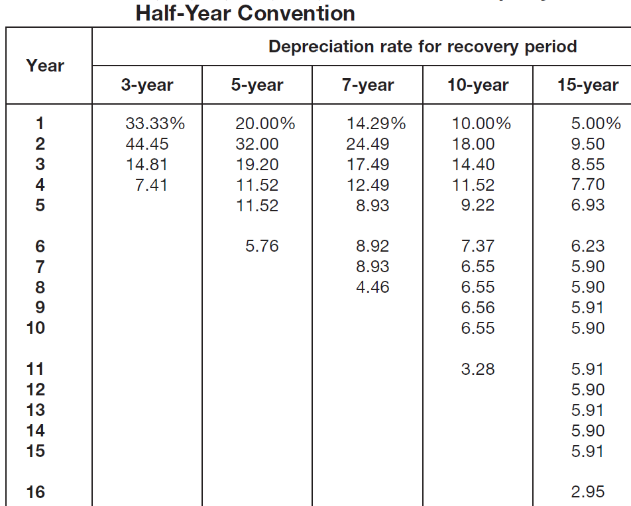 | 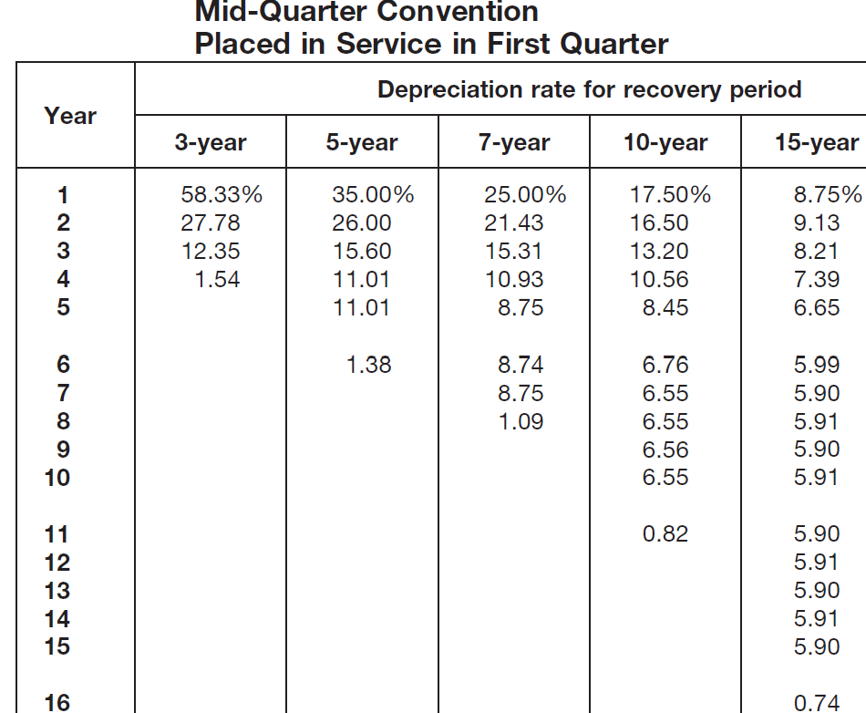

Straight Line
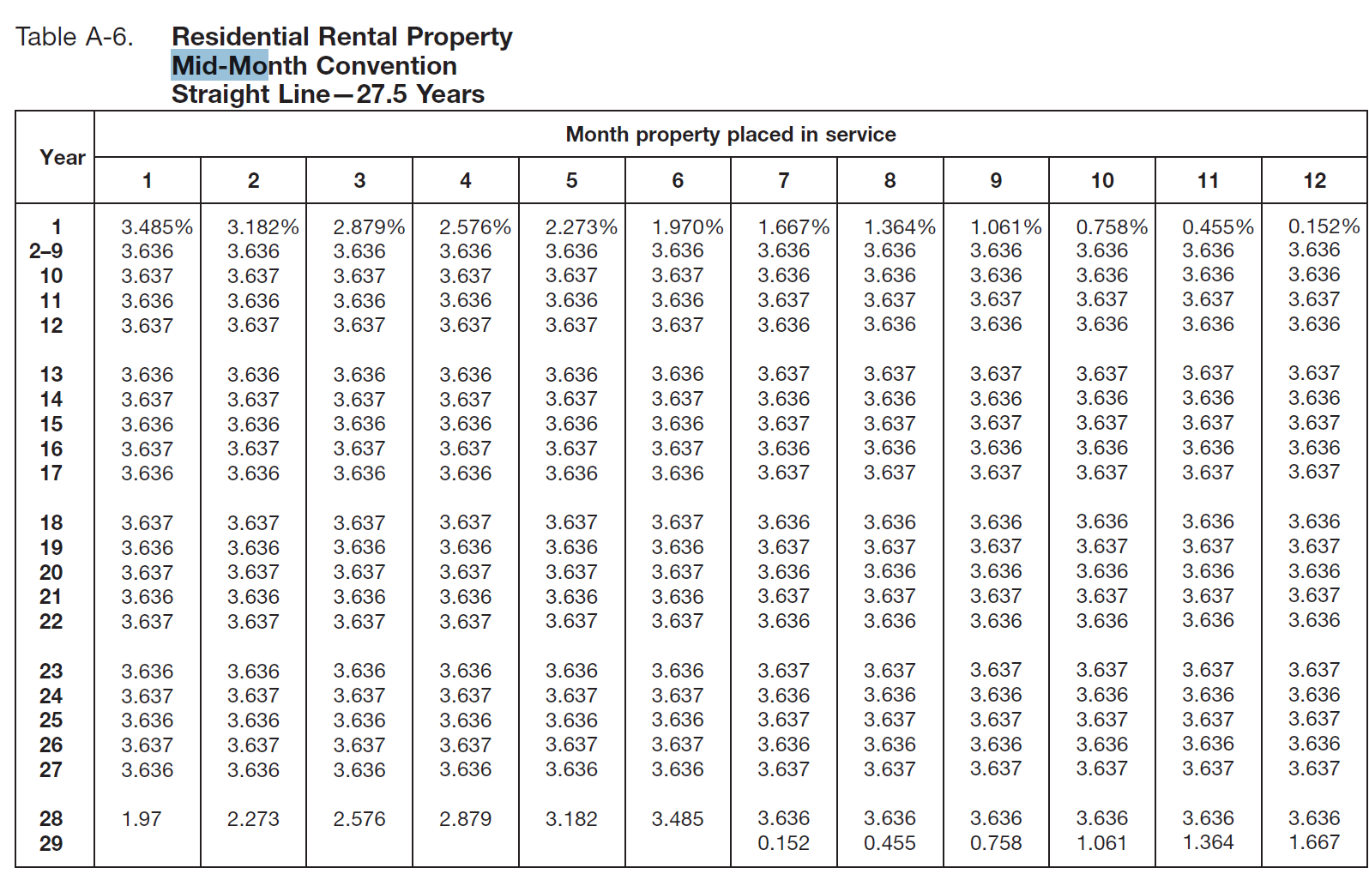

Electing a Method
You can elect a different method for depreciation for certain types of property. You must make the election by the due date of the return (including extensions) for the year you placed the property in service.

Taxable or Nontaxable
Type of Income / Benefits / Payouts | Taxable ?
Bonus, Incentives, Awards, Allowances, Sick Time, Severance Pay, Settlement, Back Pay, Moving Reimbursement, Survival Benefits | Cash --- Y  Noncash Gifts --- N
Employer Contributions to Employee’s Retirement Plan | N
Health Plans (Medical Dental Vision), Accident Plans | N  (must be in S Corp 2% Owner W2’s, then Deductible as SEHI)
Dependent Care Benefits | N
Educational Assistance | N (< $5,250)
Employee Discount | N
Fringe Benefits (Car, Flights, Travel, Vacations, Services, Membership, …) | Y
Employee Discount | N
Fringe Benefits (Car, Flights, Travel, Vacations, Services, Membership, …) | Y
Tips | Y
Workers’ Compensation (Wage Replacement, Medical Treatment, …) | N
Unemployment Benefits | Y
Scholarships | N --- for Tuition and Fees  Y --- for Room and Board etc.
Rebates, Credit Card Rewards | N
Canceled Debt | Y  N --- for Insolvency
Social, Legal and Scientific Prizes and Awards | Y
Jury Pay | Y
Social Welfare Benefits | N
Disaster Relief | N
Gifts and Inheritance | N
VA Benefits | N
Lawsuit Settlement / Legal Remedies
--- Physical Injury | N
--- Non-Physical Injury (Mental, Emotional, Defamation, Humiliation, Discrimination …) | Y
--- Punitive | Y
Life Insurance Proceeds | N
Disability Benefits – Premium Paid By Your After-Tax Money | N
Disability Benefits – Premium Paid By Your Employer or Your Before-Tax Cafeteria Plan | Y
Home and Other Property Insurance Claims, Car Insurance Claims | N

Income Not Subject to Self-Employment Tax
Interest, Dividend, Capital Gain, Sale or Disposing Property, Rental, Hobby, S Corp K-1, Limited Partner K-1 (except for guaranteed payment),
Incentive from Automotive Manufacture To An Automotive Dealer,
Nonresident Aliens

Deductible or Nondeductible
Commuting | N |  | Collecting Expenses | N
Home Office |  | If have Sch C | Credit or Debit Card Convenience Fees | N
Lunches With Co-Workers, Meals While Working Late | N |  | Disability Insurance Premiums | N
Professional Accreditation Fees | N |  | Dividend Reinvestment Service Fee | N
Travel Expenses | N |  | Fees To Collect Interest and Dividends | N
Unreimbursed Employee Exp | N |  | Investment Fees and Exp | N
Unreimbursed Employee Exp - for Persons with Disabilities | YES | Using Sch A | Life Insurance Premiums | N
Wages Never Received Or Lost Vacation Time | N |  | Loss From The Sale Of Properties | N
Adoption Expenses |  | Tax Credit - Using Form 8839 | Loss of Cash Or Property | N
All Licenses | N |  | Loss on Bank Deposits | N
Bribes And Kickbacks | N |  | Loss on IRA | N
Campaign Expenses | N |  | Passed-Through Investment Exp | N
Estate Tax | YES | Using Sch A | Ponzi-Type Investment Schemes | YES | Using Form 4684
Fines or Penalties | N |  | Repayments of Prior Year's Income |  | If >$3,000, Using Sch A
Legal Expenses | N |  | Repayments of Social Security Benefits |  | If >$3,000
Lobbying Expenses | N |  | Stock, Bonds Paper Safe Deposit Box | N
Political Contributions | N |  | Unrecovered Investment in Annuity | YES | Using Sch A
Tax Preparation Fees | N |  | Burial or Funeral, Cemetery Lot | N
Trustee's Administrative Fees | N |  | Club Due | N
Amortizable Bond Premium | YES | Using Sch A | Fitness and Health | N
Broker's Commissions | N |  | Gambling Losses Up to the Amount of Gambling Winnings | YES | Using Sch A
Capital Expenses | N |  | Hobby Expenses | N | Income Taxable, Exp Not Deductible
Casualty and Theft Losses | N |  | Home Repairs | N
Casualty and Theft Losses - of Income-Producing Property | YES | Using Form 4684 or Form 4797 | Home Security System | N
Check-Writing Fees | N

Energy Efficient Home Credit (Non-Refundable, Carryover, Form 5695) Qualified Manufacturer List：
https://www.irs.gov/credits-deductions/energy-efficient-home-improvement-credit-qualified-manufacturers

EQUIPMENT TYPE | on or Before 12/31/2025
Solar panels, Solar water heaters | 30% of cost  No annual or lifetime limit
Wind turbines, Natural gas or electric heat pumps, Biomass stoves/boilers, Battery storage technology property, Biomass stoves/boilers | 30% of cost  Up to $2,000 per year
Air conditioners | 30% of cost, up to $600 each item, up to $1,200 per year
Water heaters/water boilers | 30% of cost, up to $600 each item, up to $1,200 per year
Furnace | 30% of cost, up to $600 each item, up to $1,200 per year
Exterior doors | 30% of cost, up to $250 per door, up to a total of $500
Exterior windows and skylights | 30% of cost, up to $600
Insulation and Sealing Materials (of sidings etc.) | 30% of cost, up to $1,200 per year
Electric panel or circuit upgrades | 30% of cost, up to $600

EV Credit (Non-Refundable, NO Carryover. Before 10/01/2025. Form 8936)
https://fueleconomy.gov/feg/tax2023.shtml
MAGI (Smaller of Last and This Year) MFJ: < 300,000 HOH: < 225,000 Single & MFS: < 150,000
--- up to $7,500 --- Independent Only

Previously-Owned Clean Vehicles Credit (Non-Refundable, NO Carryover. Before 10/01/2025. Form 8936))
https://www.fueleconomy.gov/feg/taxused.shtml
MAGI (Smaller of Last and This Year) MFJ: < 150,000 HOH: < 112,500 Single & MFS: < 75,000
--- Vehicle sale price < 25,000 --- Model at least 2 years older than current year
--- Not being transferred in the past year --- up to $4,000 --- Independent Only
EV Charger (Alternative Fuel Vehicle Refueling Property Credit) (Non-Refundable, NO Carryover. 2023-2032. Form 8911))
30% of cost, up to $1,000 / Item

ID Theft

- Call the IRS, 800-908-4490 Extension 245 is for Taxpayers Not in Previous Contact with IRS

- Create a IRS Online Account https://api.id.me/en/registration/new

- Logon to your IRS Account for more information
https://www.irs.gov/payments/your-online-account

- Get an ID Protection PIN (IP PIN) from IRS Account
https://www.irs.gov/identity-theft-fraud-scams/get-an-identity-protection-pin
- Or to get an ID Protection PIN (IP PIN) by mailing Form 15227
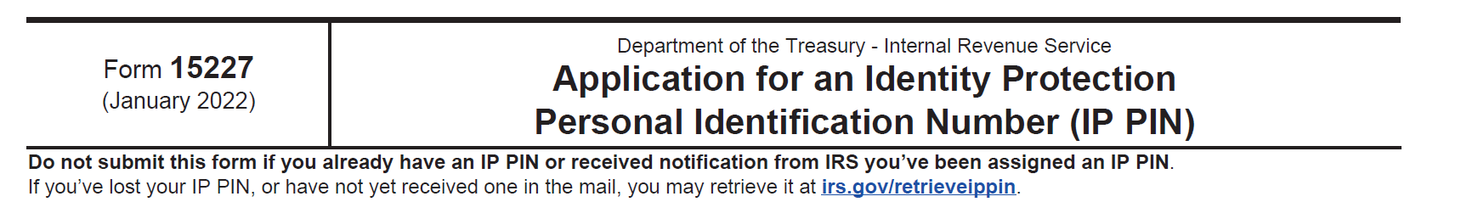

- File Form 14039 ID Theft Affidavit https://www.irs.gov/pub/irs-pdf/f14039.pdf
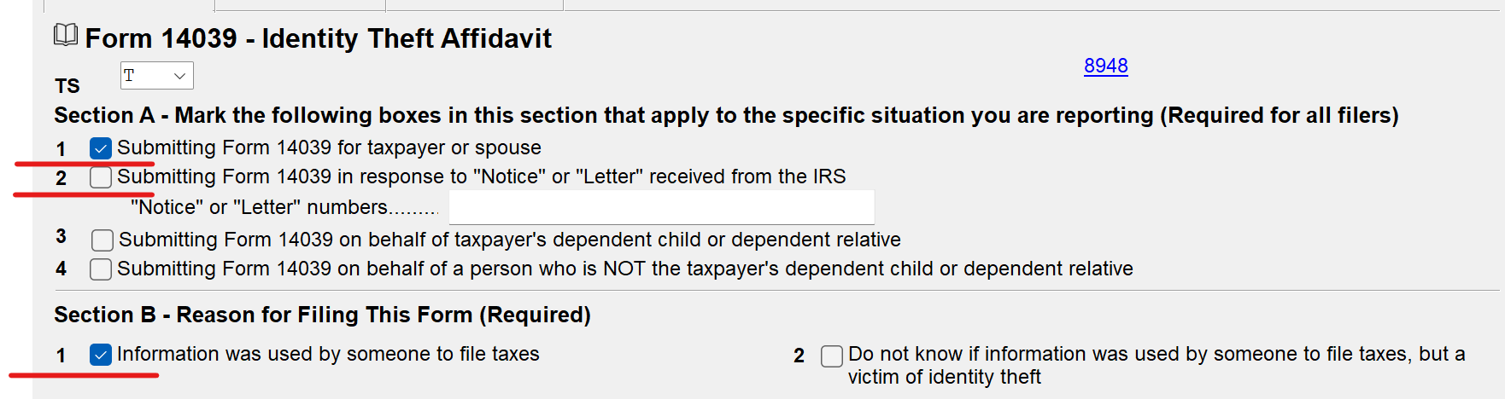

- Report ID Theft to Federal Trade Commission https://www.identitytheft.gov
- Visit the Internet Crime Complaint Center https://www.ic3.gov/ File an online report
- Notify one of the three major credit bureaus: Equifax, Experian, or TransUnion. Check your credit report for anything out of the ordinary. (You can get a free credit report at AnnualCreditReport.com)
- IRS Identity Theft Guide https://www.irs.gov/newsroom/taxpayer-guide-to-identity-theft
- Social Security Administration Office Identity Theft Guide
https://www.ssa.gov/pubs/EN-05-10064.pdf

Non US Resident Alien Taxation

 | < 183 Days | > 183 Days
Bank Interest | No | No
Dividend | 30% | 30%
Mutual Fund Dividend | No | 30%
OID | 30% | 30%
Stocks, Securities, Commodities thru a US broker | No | 30%
Stocks, Securities, Commodities by yourself | No | 30%
Gain from other Capital Assets (that is NOT Real Property) | No | 30%
Sale of US Main Home | $250K/500K exclusion | $250K/500K exclusion
Scholarships and Fellowships (for tuition) | No | No
Scholarships and Fellowships (for room, board, travel …) | same as US Person Ordinary Income Tax % | same as US Person Ordinary Income Tax %
Scholarships and Fellowships (for teaching, research) | same as US Person Ordinary Income Tax % | same as US Person Ordinary Income Tax %
Wages from Foreign Employer and Foreign Earned Income | No | No
Job Income | same as US Person Ordinary Income Tax % | same as US Person Ordinary Income Tax %
Self-Employment Income | same as US Person Ordinary Income Tax % | same as US Person Ordinary Income Tax %
Partnership Income | same as US Person Ordinary Income Tax % | same as US Person Ordinary Income Tax %
Trust or Estate Income | same as US Person Ordinary Income Tax % | same as US Person Ordinary Income Tax %
Other Business Income | same as US Person Ordinary Income Tax % | same as US Person Ordinary Income Tax %
Transportation Income | 4% | 4%
Real Property Gain | same as US Person Ordinary Income Tax % | same as US Person Ordinary Income Tax %
Gain from other Depreciable Property | same as US Person Ordinary Income Tax % | same as US Person Ordinary Income Tax %
Gambling (Bingo, Slot Machine, Lottery …) | 30% | 30%
blackjack, baccarat, craps, roulette, or big-6 wheel | No | No
dog or horse race | No | No

1040 or 1040NR?

Substantial Presence Test
You are a resident for tax purposes if you meet the substantial presence test for calendar year 2021. To meet this test, you must be physically present in the United States on at least:
- 31 days during 20X3; and
- 183 days during the 3-year period that includes 20X3, 20X2, and 20X1, counting:
  - All the days you were present in 20X3,
  - ¹/₃ of the days you were present in 20X2, and
  - ¹/₆ of the days you were present in 20X1.
Exempt individual
Do not count days for which you are an exempt individual. The term “exempt individual” does not refer to someone exempt from U.S. tax, but instead refers to anyone in the following categories.
- A student under an “F,” “J,” “M,” or “Q” visa.
- A teacher or trainee under a “J” or “Q” visa.
- Foreign government-related individual under an “A” or “G” visa.
- A professional athlete to compete in a charitable sports event.
Student – Five Calendar Year Rule
A student under an “F,” “J,” “M,” or “Q” visa can exclude U.S. days of presence as a “student” for purposes of the substantial presence test for up to five calendar years. The five-year limit is a lifetime limit that can’t be renewed.
Teacher or Trainee – Two Calendar Year Rule
A teacher or trainee under a “J” or “Q” visa can exclude U.S. day of presence as a “teacher or trainee” for purposes of the substantial presence test for up to two calendar years. However, unlike the student limit which is a lifetime limit, the teacher or trainee limit can be renewed.

After the Five / Two Calendar Year Rule
A “F,” “J,” “M,” or “Q” visa alien who otherwise meets the substantial presence test can nevertheless be treated as a nonresident for U.S. income tax purposes by: establishing that you do not intend to reside permanently in the United States and have a closer connection to a foreign country

Foreign Earned Income Exclusion 2025

Up to $130,000/ person (X2 if both spouse qualify) Req. 330 Days in 12 Consecutive Months (<35 US Vacation Days)

A 12-month period can be any period of 12 consecutive months that includes 330 full days of presence in a foreign country. If you qualify under the physical presence test for part of a year, it is important to carefully choose the 12-month period that will allow the maximum exclusion for that year. US Vacation Days not count towards the 330 days --- US Vacation Days must be less than 35 days.
Bona Fide Residence Test - Only U.S. citizens/resident who are also citizens/nationals/permanent residences of an U.S. treaty countries can use this test. Otherwise, use Physical Presence Test. US Vacation Days are more flexible.

Foreign Housing Exclusion 2023
This exclusion applies to foreign employer-paid amount only, not applies to self-employment income.

Qualified Housing Expenses: Rent, Utilities (except phone, TV, streaming, internet), Housing insurance, Fees, Furniture and parking rentals, Rental repairs.
Not qualified: Mortgage payments, Maids or housekeepers, Purchased furniture, Lavishness

Maxium Limit on Housing: See Form 2555 Instruction table, if not listed, then use $106.85//day, or 30% of $130,000/365 --- $39,000 if for 365 days.

(Minimum) Base Housing Amount: $52/day, or 16% of $130,000/365 --- $20,800 if for 365 days.

Foreign Housing Exclusion = Qualified Housing Expenses/Maxium Limit - (Minimum) Base Housing Amount (cannot be more than Total Employer-paid Amount)

Foreign Housing Deduction
This exclusion applies to foreign self-employement income only.

Qualified Housing Expenses/Maxium Limit - (Minimum) Base Housing Amount
- if there is any Employer-based Foreign Housing Exclusion applied
(cannot be more than Remaining Foreign Earned Income After All Other Exclusions)

Foreign Currency Exchange Rate

https://www.irs.gov/individuals/international-taxpayers/yearly-average-currency-exchange-rates

Foreign Tax Credit (Non-Refundable, Carryover)

(1) You cannot take a foreign tax credit for taxes on income you exclude.
Claim the Foreign Tax Credit Without Filing Form 1116： “Passive Category Income” ， and Total < $600 (MFJ)/ $300 (Others)

Passive Category Income. Interest, Dividends, Royalties, Rents, Annuities, Capital Gains, Gains from sale of property, Gains from foreign currency or commodities transactions

General Category Income: Wages/Salary, Income earned in a trade/business

If you received both Passive Category Income and General Category Income from foreign sources, you must complete two Forms 1116.

Line 1a --- Don't include any earned income excluded on Form 2555

Form 1116 Lines 2 Through 5 --- Deductions and Losses
--- reduce your foreign gross income

Line 3d. Enter your gross foreign source income from the category you checked above. Include any foreign earned income you have excluded on Form 2555 (to calculate Deduction Pro Rata)

If you had income from more than one country, you must enter income from only one country in each column.

Line 3e. Enter on line 3e in each column your gross income from all sources and all categories, both U.S. and foreign. Include any foreign earned income you have excluded on Form 2555.

Line 3g. %age = Foreign Income From This Category / Form 1040 Gross Income.
Foreign Income Deduction Allowed = Form 1116 Deduction * %age

You can carry forward 10 years any foreign tax you paid or accrued

First, apply the excess to the earliest year to which it may be carried. Then, apply it to the next earliest year, and so on.

Line 17. Net Foreign Source Taxble Income from This Category
Line 18. Total Form 1040 Taxable Income
Line 19. %age
Line 20. Total Form 1040 Tax
Line 21. Maximum Foreign Tax Credit of This Category = Total Form 1040 Tax * %age
Line 24. Foreign Tax Paid (subject to Maximum)

Form 8938 and FinCEN 114/FBAR

 | Form 8938, Statement of Specified Foreign Financial Assets | FinCEN Form 114, Report of Foreign Bank and Financial Accounts (FBAR)
Who must file? | U.S Citizens, Resident Aliens, and Certain Non-Resident Aliens; Domestic Corporations, Partnerships, and Trusts that have an interest in Foreign Financial Assets | U.S. Persons, which include U.S. Citizens, Resident Aliens, Trusts, and Domestic Entities that have an interest in Foreign Financial Accounts
Reporting threshold (total value of assets) | Specified individuals living in the US: | Aggregate value of financial accounts exceeds $10,000 at any time during the calendar year. This is a cumulative balance, meaning if you have 2 accounts with a combined account balance greater than $10,000 at any one time, both accounts would have to be reported.
  Living -- | in the US | outside the US
  Single / MFS | >50K the last day,  Or >75K at any time | >200K the last day,  Or >300K at any time
  MFJ | >100K the last day,  Or >150K at any time | >400K the last day,  Or >600K at any time
  Domestic Entities | >50K on the last day,  Or >75K at any time
When do you have an interest? | If any income, gains, losses, deductions, credits, gross proceeds, or distributions from holding or disposing of the account or asset are or would be required to be reported, included, or otherwise reflected on your income tax return | Financial interest: you are the owner of record or holder of legal title; the owner of record or holder of legal title is your agent or representative; Signature authority: you have authority to control the disposition of the assets in the account
When due? | Form is attached to your annual return and due on the date of that return, including any applicable extensions | Received by April 15 (6-month automatic extension to Oct 15)
Penalties | Up to $10,000 for failure to disclose and an additional $10,000 for each 30 days of non-filing after IRS notice of a failure to disclose, for a potential maximum penalty of $60,000 | If non-willful, up to $10,000; if willful, up to the greater of $100,000 or 50 percent of account balances.

 | Sole Proprietorship | Partnership | LLP | Single Member LLC | Multi Member LLC | C Corp | S Corp
Formation | Not registered | Not registered | Registered by State | Registered by State | Registered by State | Registered by State | Elected to IRS  (from LLP, LLC or C Corp)
Notes |  |  |  | Some states not allow professionals to form LLC’s |  |  | < 100 shareholders
Ownership | Individuals | Individuals or Any Other Type of Businesses | Individuals; Some states limit it to certain professions: Architecture, Engineering, Law, CPA | Individuals or Any Other Type of Businesses |  | Individuals or Any Other Type of Businesses | Individuals, Single Member LLC (disregarded entity), some trusts /estates. No partnerships, No corps. S Corp can own a QSub subsidiary S Corp, which does not file its own tax
Management | Self | One or more Managing Partner(s) |  | Shareholder(s) or to hire outside Manager(s)
Liabilities | Liabilities not limited | Liabilities not limited | Only liable for his own negligence, not other partners’ | Limited liabilities unless owners act illegally
Tax Form | Schedule C | Form 1065  Either a General Partner or a Limited Partner; OR BOTH |  | Schedule C | Form 1065  Either a General Partner or a Limited Partner; OR BOTH | Form 1120 | Form 1120S
Taxation | Owner | Partners | Partners | Owner | Partners | Company  And Double Taxation | Shareholders
15.
Non Resident Alien Owner? | Yes | Yes | Yes | Yes | Yes | Yes | NO  (Resident Alien OK)
Non Resident Alien Owner? | Paper-file IL REG-1, in the SSN field, specify as “Foreign National”  K-1 SSN Field = “FOREIGNUS” / “APPLD FOR"
Self-Employed? | Yes | Yes | Yes | Yes | Yes | No | No  SEHI must show in W2
15.3% Self-employment Tax | Yes | Yes | Yes | Yes | Yes | No | Officer Compensation – Yes  K1 Dividend - No

Form 2553 – Election to a S Corp
Form 8832 – Single or Multimember LLC elect to a C Corp
Statement to IRS – Revoke a S Corp, change back to a C Corp

